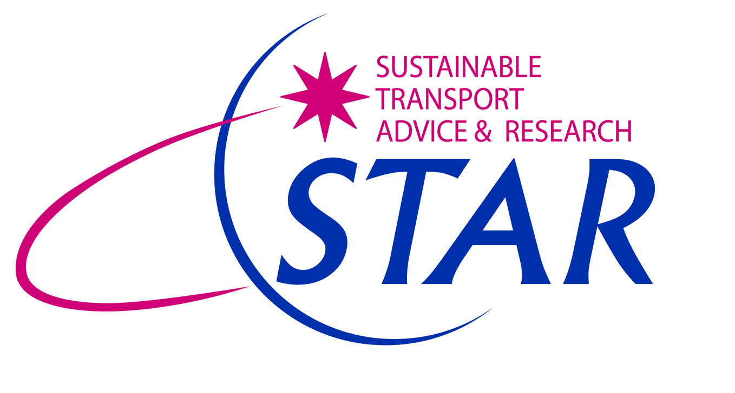

STAR Transport Training Package

STAR has considerable expertise in the provision of training in transport services to the public sector, the private sector and the voluntary and community sector. The Directors of STAR have been providing training services for over 10 years, ranging from training on EU-funded collaborative projects, through detailed seminars and workshops delivered as part of the Access Alliance Programme, to the provision of Visiting Lecturer services at Loughborough University.

STAR has now developed the STAR Transport Training Package, consisting of 8 transport modules:

- Module 1 Developing transport networks at minimum cost
- Module 2 Developing and monitoring community transport schemes
- Module 3 Developing cost-effective SEN and mainstream school transport services
- Module 4 Managing transport projects
- Module 5 Monitoring and evaluating transport projects
- Module 6 Developing fruitful partnerships across the sectors
- Module 7 Engaging with private industry / bus operators
- Module 8 Developing smarter choices schemes

These modules may be customised to the requirements of the client. The advantage of the Transport Training Package is that staff may be trained at the client’s own offices, minimising time away from work. The cost of the Package per member of staff trained is minimal in contrast with the cost of paying for training via external courses and conferences.

The principles behind the Package are to assist local authority staff to enhance their knowledge and skills to make a more effective contribution within their authority. This is particularly important in these challenging economic times, when staff may be required to take on new and additional duties for which they have not necessarily been formally trained. The Package stresses the importance of flexibility in attitude, adaptability and the notion of breaking down barriers to assist partnership working.

The advantage for the client is that their staff are better placed to undertake work in-house in the future, which in previous times may have been placed with external third parties. The Package will encourage the participants to think of their wider responsibilities and of how they can work together with colleagues from other departments to provide the best possible service to their employer and, by extension, to the residents of their authority area.

Each module contains a core of technical work which will increase the overall knowledge and awareness of the participants. Another key feature is the interactivity and group discussions between the participants which will enable them to appreciate the benefits of partnership working with other departments and teams. Most of all, the modules will encourage team building and workplace bonding between the client’s staff drawn from different teams / departments, who will be required to work closely together in the future in order to be as effective as possible. STAR makes extensive use of real world case study examples, many of them drawn from their own experience.

STAR recently delivered a Transport Training Package (covering all 8 modules) on behalf of Nottingham City Council. The course was acknowledged to have played a key role in breaking down barriers between teams within the Transport Department, as well as greatly enhancing the knowledge and skills of the participants over a range of transport and management topics. A total of 28 staff members were trained over 4 days; the training was well received by the client and by the course participants. A few of the comments received were:

”Discussion topics were really useful and well thought out”

“Excellent day; good examples for case study”

“Good theoretical approach, good level of detail pitched at the right level. Good chance to re-evaluate the project I’m working on”

“Really enjoyable, excellent delivery, well presented, good relevant comment. Great!”

“The structure, delivery and presentation were the best I have ever had.”

“Thanks for putting the event on; I would like to attend more sessions from STAR”

Why not contact STAR to discuss how we can assist you to get the best out of your staff? We can discuss a variety of training options with you, including any new modules or particular customisation you may require, and provide you with a very reasonable quotation!!

Norman James, Director
STAR Independent Consultants Ltd
07917 692443 / 07867 871405
norman@startransport.co.uk
www.startransport.co.uk

